The data mart should be designed to answer the following questions:

(our focus was on Toronto and Ottawa) (in a period of four months)

1. What were the trends, in terms of the number of cases, over time? (Our aim is obtaining profiles of individuals, by age and gender, who tested positive for Covid-19; distinguishing between travel-related and other cases (if known); tracking outbreaks; exploring the types and availability of testing facilities; etc.)

🡪 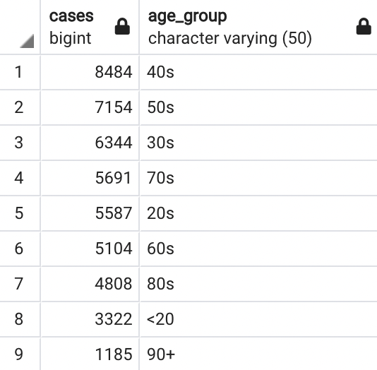 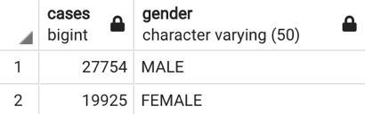

1. Was there any interplay between special events (e.g., Thanksgiving or Canada Day) and the number of cases? (It should be noted that there is typically a delay between increased social interactions and an upsurge in positive Covid-19 tests.)

🡪

1. How did lockdown measures, such as stay at home orders or school closures, affect the number of cases? Did specific government announcements or restrictions lead to downward trends in the number of cases? (The effectiveness of specific government measures on the outbreak is of importance here. It should again be noted that there is typically a delay between restrictions and a decreased in positive Covid-19 tests.)

🡪

1. What were the trends in behaviors, in terms of the locations people visited and the duration they stayed? Did the weather have any impact on these trends? For instance, studies suggested that many Canadians started bicycling, walking, or visiting parks during the summer. (This question speaks to the mapping of potential changes in citizens’ lifestyles. Note that mobility data are available online from e.g., the google mobility repository and that weather data may be obtained from Environment and Climate Change Canada.)

🡪 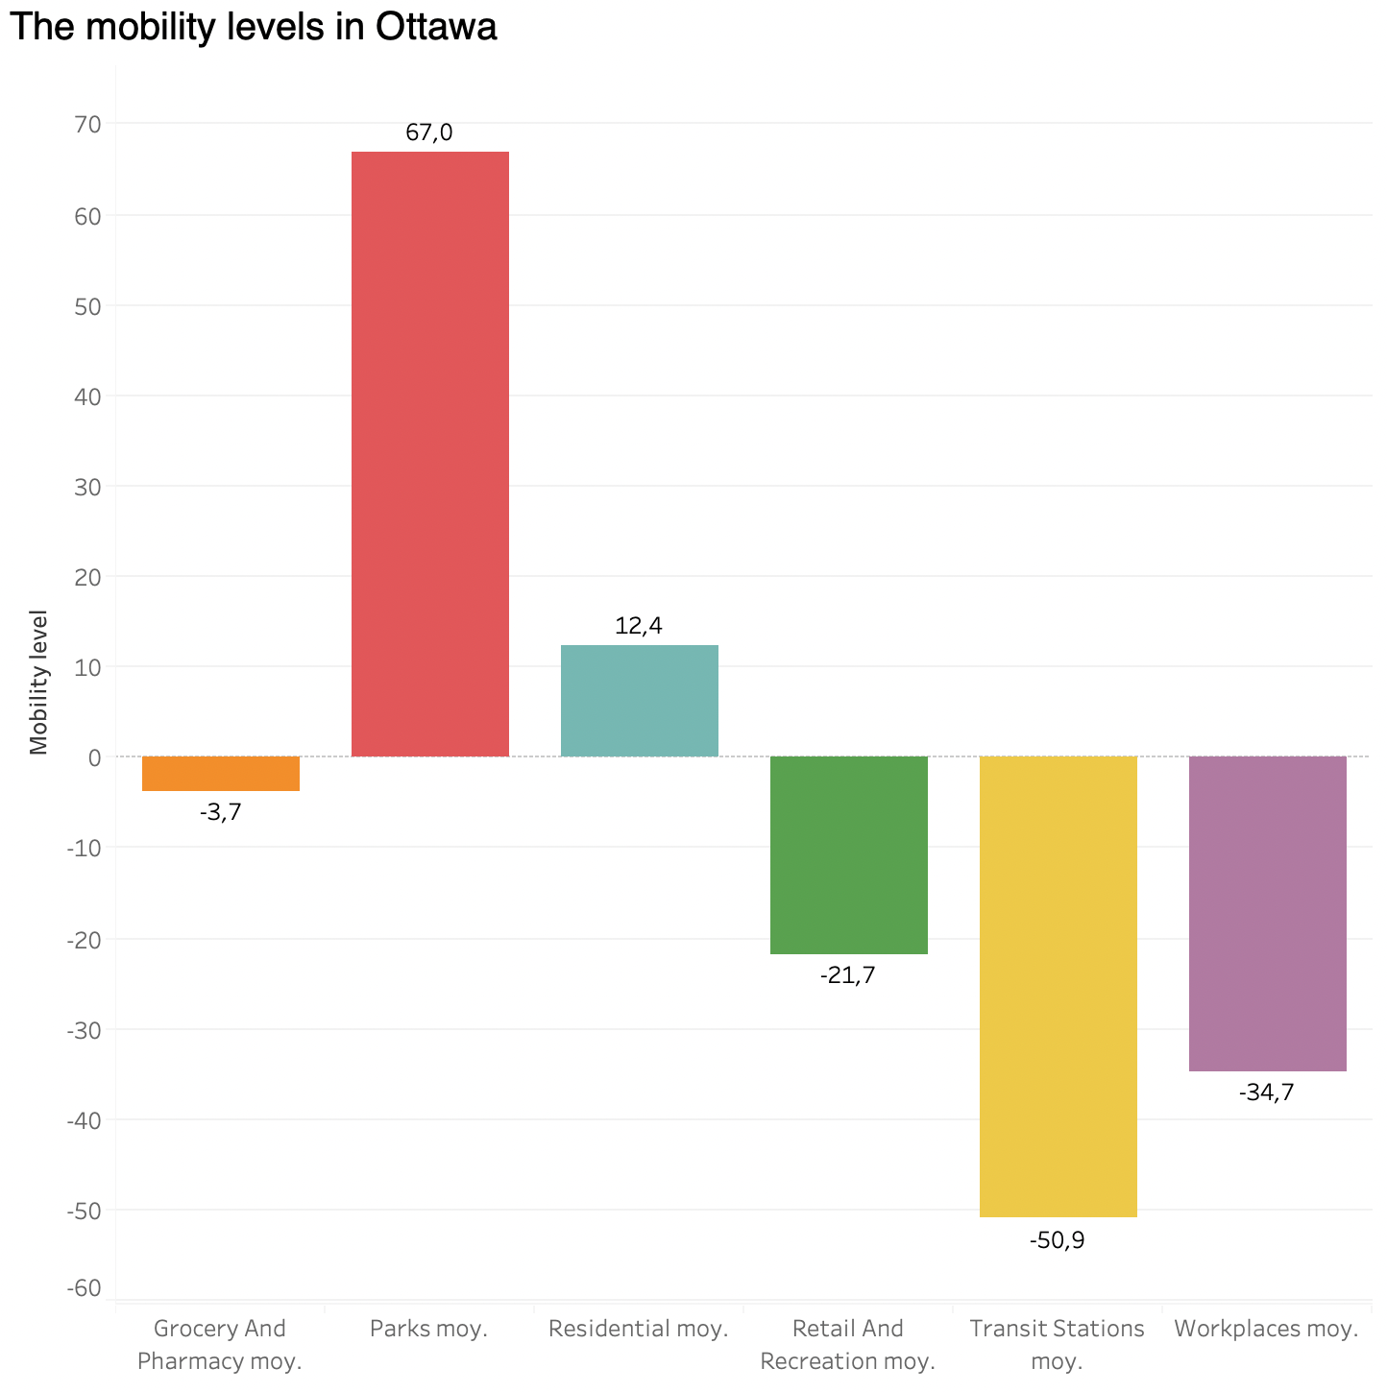

From the results we got, we can say the people were visiting parks and staying at home more often than they normally do, while avoiding visiting retails stores, transit stations, and the workplace